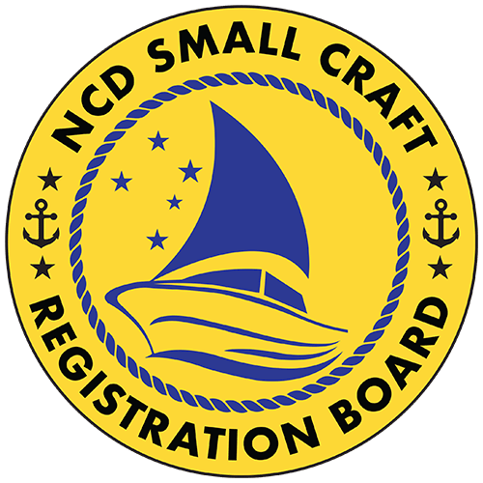

Meeting Pack
NCD Small Craft Registration Board Meeting No.1
2025



NCD SCRB Meeting No.1, 2025
9.00am

Agenda
- Call to Order
  - Chairperson to open the meeting
- Attendance
2.1 Present
2.2 Apologies
2.3 Absent
- Disclosure of Conflict of Interest
- Confirmation of Previous Records
4.1 Minutes of Previous Meeting (if applicable)
4.2 Ratification of any Circular Resolutions
- Matters Arising from Previous Meetings
- Correspondence
6.1 Correspondence from the Water Police – Draft MOU between the RPNGC Water Police Directorate and NCD SCRB (for discussion and approval)
- Business of the Meeting
  - Registrar’s Report – Hitolo Garia, Registrar
    - Overview of operational updates, challenges, and 2026 readiness
    - Discussion on MOU partnership framework with NCDC–MKA and Water Police
  - Financial & Budget Reports
    - Review of 2025 Financial Report (as at 9 October 2025)
    - Endorsement of 2025 Budget Summary
    - Approval of the Draft 2026 Budget Forecast (including Operational, Programme, and Remuneration Budgets)
    - Discussion on Remuneration Budget (Direct Costs, On-Costs, Summary)
  - NCD SCRB Regulation
    - Overview and discussion on proposed supplementary provisions to complement the Small Craft Act 2011 (see separate document attached for Board review).
  - Calendar of Events / Work Plan (2025–2026)
    - Key awareness, registration, and enforcement programs
- Other Business
  - Items raised by Board Members
- Closure
- Date of Next Meeting
  - To be confirmed

